**Red Team: Summary of Operations – TARGET1**

**Table of Contents**

* Exposed Services
* Critical Vulnerabilities
* Exploition

**Exposed Services**

Nmap scan results for each machine reveal the below services and OS details:

$ nmap -sV 192.168.1.110

This scan identifies the services below as potential points of entry:

* Target 1
  + Port 22 SSH
  + Port 80 HTTP

The following vulnerabilities were identified on each target:

* Weak passwords
* User enumeration
* Unsalted hashed passwords
* Sql database password in plain text
* Privilege escalation via python script

**Exploitation**

The Red Team was able to penetrate Target 1 and retrieve the following confidential data:

**User Enumeration**

wpscan –url http://192.168.1.110/wordpress --enumerate u. Users Michael and Steven were discovered.

**Weak Passwords**

Michael’s password was guessed and was able to gain access via ssh.

Once logged in as Michael, we navigated to /var/www/html and were able to find flag1

Flag 1

Flag 2 was located one directory above flag 1

**SQL Database Password in plain text**

The password for the database was found in plain text within the wp-config.php file.

Using the following commands was able to access the database

-Mysql -u root -p’R@v3nSecurity’

-show databases;

-use wordpress;

-show tables

-show wp-users

Flag 3

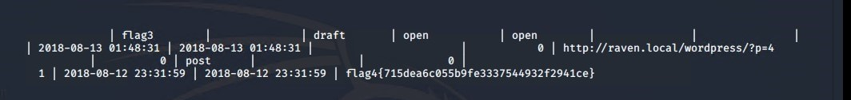

**Unsalted Hashed Passwords**

Using the following commands was able to access the database

-Mysql -u root -p’R@v3nSecurity’

-show databases;

-use wordpress;

-show tables

-select wp-users

Flag 4

-created a new file called hashes.txt and added the hashed passwords for both Michael and steven. Then ran the file through “john”

Discovered Stevens password was “Pink84”

**Privilege Escalation via Python Script**

In order to escalate to root, used a python script to gain root access.

